PROJECT PLANNING PHASE
Project Planning Template
Date | 03 October 2026
Team ID | SWTID-2026-8740
Project Name | Employee Data Management using ServiceNow Import Sets and Transform Maps
Maximum Marks | 5 Marks
Product Backlog, Sprint Schedule, and Estimation
The backlog below translates the completed project into manageable stories. Priorities reflect the dependency of each task on the import workflow: data intake and transformation are completed before reporting and dashboard work.
Sprint | Functional Requirement (Epic) | User Story Number | User Story / Task | Story Points | Priority | Team Members
Sprint-1 | Data Import | USN-1 | As an administrator, I can prepare the employee spreadsheet with the required employee fields. | 2 | High | Project Team
Sprint-1 | Data Import | USN-2 | As an administrator, I can load the employee spreadsheet into the ServiceNow Import Set. | 1 | High | Project Team
Sprint-1 | Data Configuration | USN-3 | As an administrator, I can create the Employee Test table and configure the required employee fields. | 3 | High | Project Team
Sprint-1 | Data Configuration | USN-4 | As an administrator, I can create a Transform Map that maps imported employee fields to the target table. | 3 | High | Project Team
Sprint-1 | Data Quality | USN-5 | As an administrator, I can use Employee ID as the Coalesce field so existing employees are updated instead of duplicated. | 3 | High | Project Team
Sprint-2 | Reporting | USN-6 | As an administrator, I can view employee counts by department in a report. | 2 | Medium | Project Team
Sprint-2 | Reporting | USN-7 | As an administrator, I can view employee counts by location in a report. | 2 | Medium | Project Team
Sprint-2 | Reporting | USN-8 | As an administrator, I can view employee records in a list report. | 2 | Medium | Project Team
Sprint-2 | Dashboard | USN-9 | As an administrator, I can view the employee reports together on an analytics dashboard. | 5 | Medium | Project Team
Sprint-2 | Validation | USN-10 | As an administrator, I can verify insert, update and repeated-import behavior after transformation. | 5 | High | Project Team
Project Tracker, Velocity & Burndown Chart
The project is represented as a two-sprint plan because the supplied planning logic uses two sprints. Calendar start/end dates and actual release dates were not provided in the source material, so they are marked as not specified.
Sprint | Total Story Points | Duration | Sprint Start Date | Sprint End Date (Planned) | Story Points Completed (as on Planned End Date) | Sprint Release Date (Actual)
Sprint-1 | 12 | Not specified | Not specified | Not specified | 12 planned | Not specified
Sprint-2 | 16 | Not specified | Not specified | Not specified | 16 planned | Not specified
Velocity
Using the two-sprint plan: total story points = 12 + 16 = 28. Average velocity = 28 / 2 = 14 story points per sprint.
Burndown Chart – Planned View
Because actual daily completion data is not included in the supplied project material, the chart below is a planned reference view rather than a claim about actual daily progress.
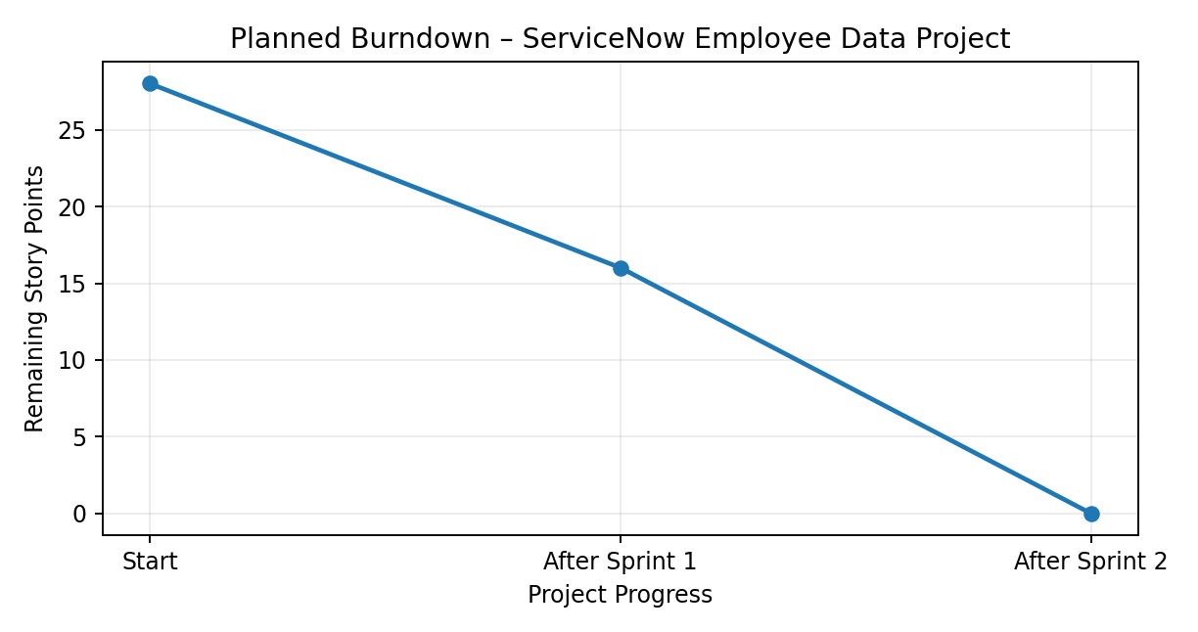
Figure 1: Planned story-point burn based on the two-sprint backlog.
Planning Assumptions and Limitations
- The backlog is derived from the actual project workflow: spreadsheet preparation, import, target-table configuration, Transform Map, Coalesce, reports and dashboard.
- The source planning material does not provide the team's actual names, calendar schedule or day-by-day completion records; therefore these fields are not fabricated.
- The velocity shown here is a planning estimate derived from the documented story-point allocation, not a measured historical team velocity.
References
Supplied Planning logic document and Project Planning Template.
Agile/Scrum terminology and burndown-chart structure follow the terminology and organization provided in the supplied templates.

